**Software Testing Assignment**

Module-1(Fundamental)

* **What is SDLC?**
* SDLC Stands for “Software Development Life Cycle”.

There are 6 phases of SDLC

1. Requirements
2. Analysis
3. Design
4. Implementation
5. Testing
6. Maintenance

* **What is software testing?**
* Software testing is process used to identify the CORRECTNESS, COMPLETENESS and QULAITY of developed computer software.
* **What is agile methodology?**
* No project deadline in agile model.
* Agile model used to product based company.
* Agile model is combination of iterative & incremental model.
* Agile model is developed instantly.
* No rigidity in agile model.
* Agile model in team work & cross training available.
* At a time, all phases work available in agile model.
* These all project handle by different types.
* **What is SRS?**
* SRS stands for “Software Requirement Specification” is a complete description of the behavior of the system to be developed.
* There are 3 types of requirements

1. Customer requirements
2. Functional requirements
3. Non-functional requirements

**1). Customer requirements**

* Customer requirements including all the information about the software like:
* What is the purpose of this software?
* How this software is use?
* In which environment software will work?
* What are the functionality of this software?

**2). Functional requirements**

* A functional requirement means that the possibility is 100%.
* Functional requirement is including technical requirement.
* Technical requirement done by developers in coding phase.

**3). Non-functional requirements**

* Non-functional requirements mean that it is possible but only for a short time.
* Non-functional requirements can be divided into following categories:
* Usability
* Reliability
* Performance
* Security
* **What is OOPs?**
* OOPs stands for “Object Oriented Programming”.
* Identifying objects and assigning responsibilities to these objects.
* **Write Basic Concepts of OOPs.**
* There are 6 features:

1. Object
2. Class
3. Encapsulation
4. Inheritance
5. Polymorphism
6. Abstraction

* **What is Object?**
* Any entity which has own state & behavior.
* For example: pen, paper, etc.
* **What is class?**
* Collection of object or data members.
* For example: human, body, etc.
* **What is Encapsulation?**
* Wrapping up or binding of data.
* For example: capsule, etc.
* **What is Inheritance**?
* When one object acquires all the properties & behavior of parent class.
* For example: father, son, etc.
* **What is Polymorphism?**
* Many ways to perform anything.
* Polymorphism means “having many forms”.
* **Draw Use case on online Book Shopping.**

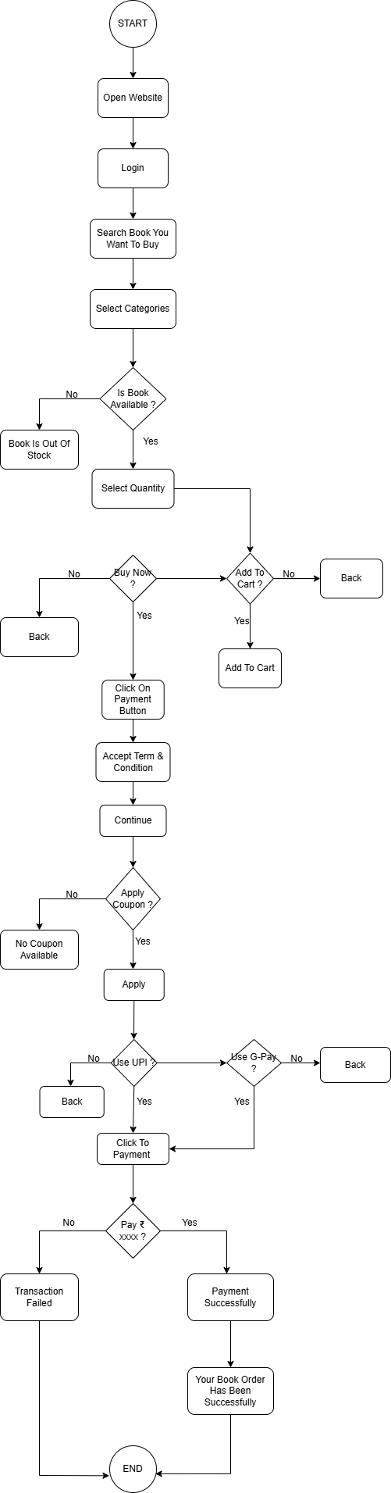

* **Draw Use case on online bill payment system(Paytm).**

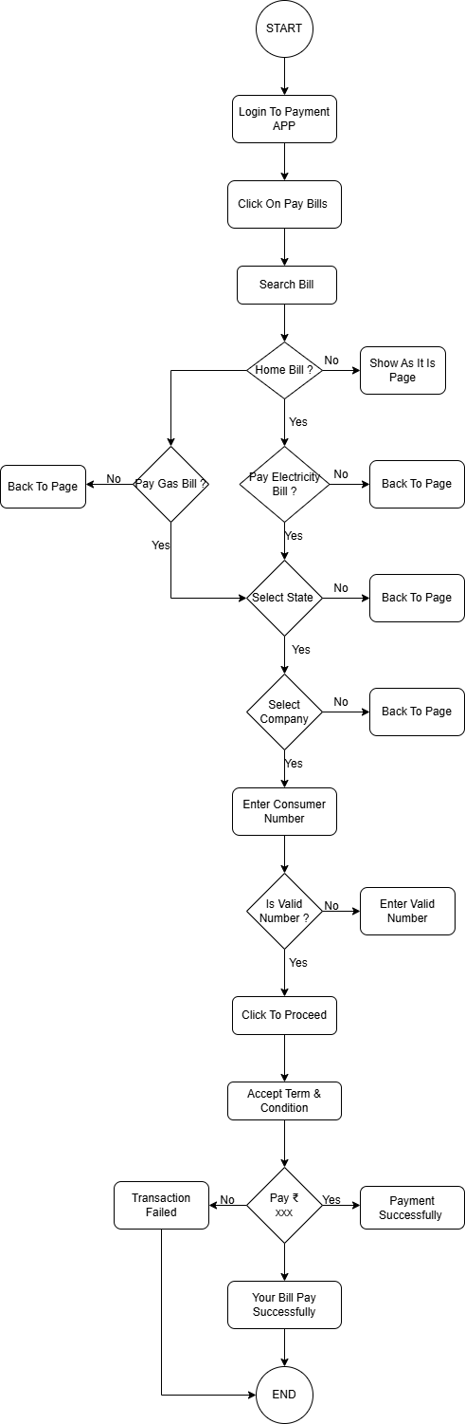

* **Write SDLC phases with basic introduction.**

There are 6 phases of SDLC

1. Requirements
2. Analysis
3. Design
4. Implementation
5. Testing
6. Maintenance
7. **Requirements:**

* In requirement phase the team is discussing with client that which requirement are needs for this project.
* Requirements can be captured in written format, diagram format, & table format.
* There are two types of requirements:

1. Functional requirement.
2. Non-functional requirement.
3. **Analysis:**

* In analysis sector you have to check WHAT should be done and HOW it can be work.

1. **Design:**

* In design phase you have to design a structure or architecture which will done by web designer, graphic designer, UX & UI.

1. **Implementation:**

* Developer will work here either it will be web developer or APP developer.

1. **Testing:**

* In testing sector manual tester, software tester, QA & QC developer will work.
* In testing, tester will check QUALITY first.
* There are so many testing:

1. Regression.
2. Internal.
3. Unit.
4. Application.
5. Stress.
6. **Maintenance:**

* After production you have to maintained product.
* Types of maintenance:

1. Corrective.
2. Adaptive.
3. Perfective.

* **Explain phases of the waterfall model.**

There are 6 phases of SDLC

1. Requirements collection
2. Analysis
3. Design
4. Implementation
5. Testing
6. Maintenance
7. **Requirements Collection:**

* In requirement phase the team is discussing with client that which requirement are needs for this project.
* Requirements can be captured in written format, diagram format, & table format.
* There are two types of requirements:

1. Functional requirement.
2. Non-functional requirement.
3. **Analysis:**

* In analysis sector you have to check WHAT should be done and HOW it can be work.

1. **Design:**

* In design phase you have to design a structure or architecture which will done by web designer, graphic designer, UX & UI.

1. **Implementation:**

* Developer will work here either it will be web developer or APP developer.

1. **Testing:**

* In testing sector manual tester, software tester, QA & QC developer will work.
* In testing, tester will check QUALITY first.
* There are so many testing:

1. Regression.
2. Internal.
3. Unit.
4. Application.
5. Stress.
6. **Maintenance:**

* After production you have to maintained product.
* Types of maintenance:

1. Corrective.
2. Adaptive.
3. Perfective.

* **Write phases of spiral model.**
* There are 4 phases of spiral model

1. Planning.
2. Risk Analysis.
3. Engineering.
4. Customer evolution.

* **Planning:**
* In this phase the team will make a plan about the project and they discuss about the requirements which are company demanded.
* They will design a structure according the project.
* **Risk Analysis:**
* In risk analysis the team will check any risk occurs in the future or not**.**
* They check all the scenario like the budget or cost, major requirements, environment setup and then decide we have to go for the next step or not. That is called Go, No-Go decision.
* **Engineering:**
* In this phase the team will development of the product which is discuss in next phase.
* **Customer evolution:**
* In customer evolution they check product based on customer review.
* If the customer is satisfying with current product, then they will go on the next requirement.

And this cycle is running until the product will not fully made.

* **Explain working methodology of agile model and also write pros and cons.**
* No project deadline in agile model.
* Agile model used to product based company.
* Agile model is combination of iterative & incremental model.
* Agile model is developed instantly.
* No rigidity in agile model.
* Agile model in team work & cross training available.
* At a time, all phases work available in agile model.
* These all project handle by different types.
  + **Pros:**
* Is a very Practical approach to software development.
* Promotes teamwork and cross training.
* Functionality can be developed quickly and demonstrated.
* Resource demand are minimum.
* Easy to manage.
  + **Cons:**
* Not suitable for handling complex dependencies.
* More risk of sustainability, maintainability and extensibility.
* There is very high individual dependency, since there is minimum documentation generated.
* Transfer of technology to new team members may be quite challenging due to lack of documentation.
* **Draw use case on COD & Payment gateway.**

